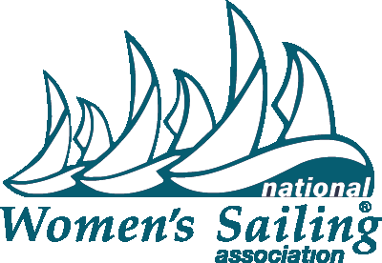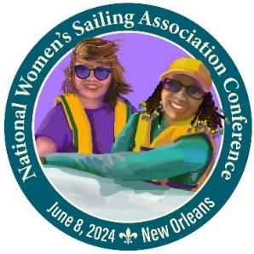

**FOR IMMEDIATE RELEASE**

April 20, 2024

Photos, logos and posters available in the [Press Room](https://womensailing.org/press/) on www.womensailing.org

Press Contact: Naomi Emmerson, 512-903-0317, [secretary@womensailing.org](mailto:secretary@womensailing.org) for interview requests

**2024 National Women’s Sailing Association Conference**

**Presented by Allstate Sugar Bowl**

**will be held June 8 in New Orleans**

The National Women’s Sailing Association (NWSA) is holding their **2024 National Women’s Sailing Association Conference presented by Allstate Sugar Bowl** on Saturday June 8 from 8:30 am – 5 pm at Southern Yacht Club on Lake Pontchartrain, New Orleans with support from Community Sailing New Orleans. The all-day event welcomes women sailors of all levels and ages to workshops including the popular Take the Helm® track — an introduction to sailing for women. A sailing scholarship fundraising mixer will be held after the conference to continue networking.

Programming includes a full day of classroom, dockside and on-the-water workshops taught by experienced female instructors and Captains from across the nation. Sailors can fine tune their spinnaker sail trim skills, practice navigation using paper and electronic charts, learn how to recover a crew overboard with a Lifesling and more. Breakfast and lunch will be provided as well as a post-event fundraising raffle and silent auction for scholarships and AdventureSail and cocktail social hour.

Highlights of the event are for all registrants. The luncheon presenter will announce the **2024 BoatUS/NWSA Leadership in Women’s Sailing Award** recipient, co-sponsored by NWSA and BoatUS. This award recognizes an individual with a record of achievement in inspiring, educating and enriching the lives of women through sailing. We are proud to have **Keynote Speaker Women’s Sailing Advocate Gail Hine** who has been inspiring to women’s sailing organizations and individuals.

Our valued sponsors are Allstate Sugar Bowl, American Sailing, BoatUS, Gulf Coast Bank and Trust Company, Pontchartrain Yacht Club, Offshore Sailing School, Louisiana Sailing School and Mantus Marine.

NWSA Member Registration Pre-Opening special runs March 1-15 at $199. Early Bird General Registration runs March 16-April 14 & General Registration runs April 15-June 4 with continued savings for members. $199 - $279 Registration details can be found on <https://www.womensailing.org> Direct any questions about conference registration or sponsorship opportunities to [conference@womensailing.org](mailto:conference@womensailing.org) or 985-247-8919.

**About National Women’s Sailing Association:** Founded in 1990 by Hall of Fame sailor Doris Colgate, the National Women’s Sailing Association is a program of the Women’s Sailing Foundation, Inc. a 501(c)(3) non-profit organization based in the U.S. It maintains the mission of providing education, programming and support for women sailors of all ages. The organization seeks to help women find community and mentorship among their peers, as well as create leadership and education opportunities. Through membership, donations and sponsorship, they continue to maintain AdventureSail®, a program designed for girls who wouldn’t otherwise have the opportunity to discover the joys of sailing, the Learn to Sail Youth Sailing Scholarship, the Sue Corl Sailing Scholarship and the BoatUS/NWSA Leadership in Women’s Sailing Award. For more information visit <https://www.womensailing.org>. Follow on [Facebook](https://www.facebook.com/nationalwomenssailingassociation), [YouTube](https://www.youtube.com/@womenssailingassociation), [Instagram](https://www.instagram.com/womenssailingassociation/), [Twitter](https://twitter.com/womenssailing) and [LinkedIN](https://www.linkedin.com/in/national-womens-sailing-association).