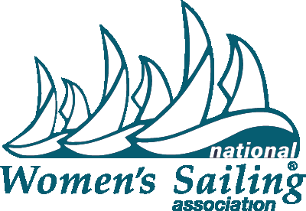
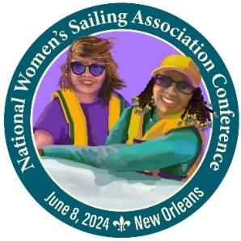

FOR IMMEDIATE RELEASE
March 1, 2024
Photos, logos and posters available in the Press Room on www.womensailing.org
Press Contact: Naomi Emmerson 512-903-0317 secretary@womensailing.org for interview requests

2024 National Women’s Sailing Association Conference
Presented by Allstate Sugar Bowl
will be held June 8, 2024 in New Orleans

The National Women’s Sailing Association (NWSA) is holding their 2024 National Women’s Sailing Conference presented by Allstate Sugar Bowl on Saturday June 8 from 8 am – 5 pm at Southern Yacht Club on Lake Pontchartrain, New Orleans with support from Community Sailing New Orleans. The all-day event welcomes women sailors of all levels and ages to workshops including the popular Take the Helm® track — an introduction to sailing for women. A sailing scholarship fundraising mixer will be held after the conference to continue networking.

Programming includes a full day of classroom, dockside and on-the-water workshops taught by experienced female instructors and Captains from across the nation. Sailors can fine tune their spinnaker sail trim skills, learn hands-on diesel maintenance, practice navigation using paper and electronic charts, learn how to recover a crew overboard with a Lifesling and more. Breakfast and lunch will be provided as well as a post-event fundraising raffle and cocktail social hour.

A highlight of the event is the announcement and presentation of the 2024 BoatUS/NWSA Leadership in Women’s Sailing Award recipient, co-sponsored by NWSA and BoatUS. This award recognizes an individual with a record of achievement in inspiring, educating and enriching the lives of women through sailing.

Our valued sponsors are Allstate Sugar Bowl, American Sailing, BoatUS, Gulf Coast Bank and Trust Company, Offshore Sailing School, Louisiana Sailing School and Mantus Marine.

NWSA Member Registration Pre-Opening special runs March 1-15 at $199. Early Bird General Registration runs March 16-April 14 & General Registration runs April 15-June 4 with continued savings for members. $199 - $279 Registration details can be found on https://www.womensailing.org Direct any questions about conference registration or sponsorship opportunities to conference@womensailing.org or (985) 247-8919.

About National Women’s Sailing Association: Founded in 1990 by Hall of Fame sailor Doris Colgate, the National Women’s Sailing Association is a program of the Women’s Sailing Foundation, Inc. a 501(c)(3) non-profit organization based in the U.S. It maintains the mission of providing education, programming and support for women sailors of all ages. The organization seeks to help women find community and mentorship among their peers, as well as create leadership and education opportunities. Through membership, donations and sponsorship, they continue to maintain AdventureSail®, a program designed for girls who wouldn’t otherwise have the opportunity to discover the joys of sailing, the Learn to Sail Youth Sailing Scholarship, the Sue Corl Sailing Scholarship and the NWSA/BoatUS Leadership in Women’s Sailing Award. For more information visit https://www.womensailing.org. Follow on Facebook, YouTube, Instagram, Twitter and LinkedIN.

